

Data Structures and Algorithms
( Course Code: CSC211 )

Name: Muhammad Abdullah
Roll No # FA24-BSE-042
Instructor Name: Sir Atique Ahmad

Lab Assignment# 1

Lab Part
Task 1:
Code Snippet
#include <iostream>
#include <vector>
#include <algorithm>
#include <numeric>
using namespace std;

class TransactionManager {
private:
vector<double> transactions;

public:
void insertTransaction(double amount) {
transactions.push_back(amount);
}

void deleteTransaction(int index) {
if (index >= 0 && index < transactions.size()) {
transactions.erase(transactions.begin() + index);
} else {
cout << "Invalid index!\n";
}
}

void findAndUpdate(double oldAmount, double newAmount) {
for (double &t : transactions) {
if (t == oldAmount) {
t = newAmount;
}
}
}

void calculateStatistics() {
if (transactions.empty()) {
cout << "No transactions available!\n";
return;
}

int count = transactions.size();
double maxVal = *max_element(transactions.begin(), transactions.end());
double minVal = *min_element(transactions.begin(), transactions.end());
double sum = accumulate(transactions.begin(), transactions.end(), 0.0);
double avg = sum / count;

cout << "Statistics -> count=" << count
<< ", max=" << maxVal
<< ", min=" << minVal
<< ", avg=" << avg << "\n";
}

void displayTransactionsSorted(bool ascending = true) {
vector<double> sorted = transactions;
if (ascending)
sort(sorted.begin(), sorted.end());
else
sort(sorted.rbegin(), sorted.rend());

cout << "Transactions: ";
for (double t : sorted) cout << t << " ";
cout << "\n";
}

void displayTransactions() {
cout << "Transactions: ";
for (double t : transactions) cout << t << " ";
cout << "\n";
}
};

int main() {
TransactionManager transaction;

// Insert
transaction.insertTransaction(2500);
transaction.insertTransaction(3200);
transaction.insertTransaction(1800);
transaction.insertTransaction(2500);
transaction.insertTransaction(4000);

transaction.displayTransactions();

// Delete transaction at index 2
transaction.deleteTransaction(2);
transaction.displayTransactions();

// Update all 2500 → 2600
transaction.findAndUpdate(2500, 2600);
transaction.displayTransactions();

// Stats
transaction.calculateStatistics();

// Descending
transaction.displayTransactionsSorted(false);

return 0;
}

Output
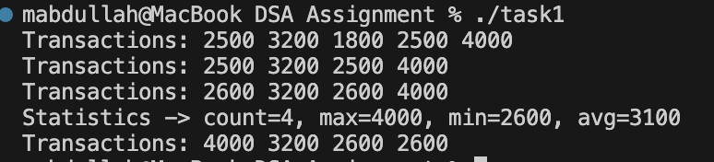

Explanation

→ Class Definition (TransactionManager)
Manages a list of transactions using a vector<double>.
→ insertTransaction(double amount)
Adds a new transaction amount to the list.
→ deleteTransaction(int index)
Deletes a transaction at the given index if it’s valid; otherwise shows “Invalid index!”.
→ findAndUpdate(double oldAmount, double newAmount)
Finds all transactions equal to oldAmount and updates them to newAmount.
→ calculateStatistics()
Calculates and displays:
- Count → number of transactions
- Max → highest amount
- Min → lowest amount
- Average → total sum ÷ count
Uses max_element, min_element, and accumulate.
→ displayTransactionsSorted(bool ascending = true)
Displays all transactions sorted in ascending or descending order (without changing the original list).
→ displayTransactions()
Displays all transactions in the order they were inserted.
→ main() Function
- Creates a TransactionManager object.
- Inserts 5 transactions.
- Displays all transactions.
- Deletes the transaction at index 2.
- Updates all 2500 → 2600.
- Calculates and displays statistics.
- Displays transactions sorted in descending order.

Task 2:
Code Snippet
#include <iostream>
using namespace std;

class Node {
public:
int data;
Node* next;
Node(int data, Node* nextPtr = nullptr) : data(data), next(nextPtr) {}
};

class LinkedList {
public:
Node* head;
Node* firstHalf;
Node* secondHalf;
LinkedList(Node* headPtr = nullptr) : head(headPtr) {}

void insert(int data){
Node* newNode = new Node(data);
newNode->next = head;
head = newNode;
}

Node* splitList(Node* head){
int count = 0;
Node* current = head;
while (current != nullptr){
count++;
current = current->next;
}
int half = count / 2;
secondHalf = head;
for (int i = 0; i < half; i++){
secondHalf = secondHalf->next;
}
current = head;
firstHalf = current;
for (int i = 0; i < half - 1; i++){
current = current->next;
}
current->next = nullptr;
return (count == 0) ? nullptr : secondHalf;

// Node* slow = head;
// Node* fast = head;
// while (fast != nullptr && fast->next != nullptr){
// slow = slow->next;
// fast = fast->next->next;
// }
// Node* secondHalf = slow->next; // fast will be at the end of the list, so slow will be at the middle. Therefore second half will start after the middle one, so we are assigning to slow->next.
// slow->next = nullptr; // and in the middle, we are assigning the mid one's next to nullptr, so that it becomes the tail of the first half.
// return secondHalf; // Return the second half of the list
}

void displayFirstHalf(){
Node* current = firstHalf;
while (current != nullptr){
cout << current->data << " ";
current = current->next;
}
}

void displaySecondHalf(){
Node* current = secondHalf;
while (current != nullptr){
cout << current->data << " ";
current = current->next;
}
}

void displaySortedDescending(Node* head) {
Node* sorted = nullptr;
Node* current = head;
while (current != nullptr) {
// Insert current->data into the sorted list in descending order
Node* newNode = new Node(current->data);
if (sorted == nullptr || newNode->data > sorted->data) {
newNode->next = sorted;
sorted = newNode;
} else {
Node* temp = sorted;
while (temp->next != nullptr && temp->next->data > newNode->data) {
temp = temp->next;
}
newNode->next = temp->next;
temp->next = newNode;
}
current = current->next;
}
// Print the sorted list
Node* temp = sorted;
while (temp != nullptr) {
cout << temp->data << " ";
Node* toDelete = temp;
temp = temp->next;
delete toDelete;
}
}

void displayList(){
Node* current = head;
while (current != nullptr){
cout << current->data << " ";
current = current->next;
}
}
};

int main() {
LinkedList list;
list.insert(5);
list.insert(5);
list.insert(3);
list.insert(8);
list.insert(1);
list.insert(4);
// Display the original list
cout << "Original list: ";
list.displayList();
cout << endl;

// Split the list into two halves
Node* secondHalf = list.splitList(list.head);

// Display the first half
cout << "First half: ";
list.displayFirstHalf();
cout << endl;

// Display the second half
cout << "Second half: ";
list.displaySecondHalf();
cout << endl;

// Display the first half sorted
cout << "First half sorted: ";
list.displaySortedDescending(list.firstHalf);
cout << endl;

// Display the second half sorted
cout << "Second half sorted: ";
list.displaySortedDescending(list.secondHalf);
cout << endl;

return 0;
}

Output
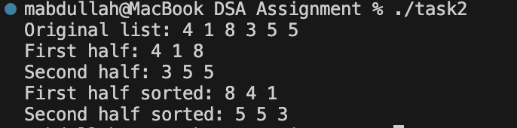

Explanation

→ Node Class
Represents a single node in the linked list.
Each node stores:
- data → the integer value
- next → pointer to the next node
→ LinkedList Class
Manages the linked list and provides functions for insertion, splitting, and displaying.
→ insert(int data)
- Creates a new node and inserts it at the beginning of the list.
- Updates head to the new node.
→ splitList(Node* head)
- Counts the total number of nodes.
- Divides the list into two halves:
  - firstHalf → first part of the list
  - secondHalf → second part after the midpoint
- Breaks the connection between both halves by setting the middle node’s next to nullptr.
- Returns the head of the second half.
→ displayFirstHalf()
Traverses and prints all nodes of the first half.
→ displaySecondHalf()
Traverses and prints all nodes of the second half.
→ displaySortedDescending(Node* head)
- Sorts the given linked list in descending order without modifying the original one.
- Builds a new sorted list by inserting each node in correct position.
- Prints the sorted nodes and deletes them afterward (to free memory).
→ displayList()
Prints the entire linked list in its current order.
→ main() Function
- Creates a linked list and inserts the values: 4, 1, 8, 3, 5, 5.
- Displays the original list.
- Splits the list into two halves.
- Displays both halves separately.
- Displays both halves sorted in descending order.

Task 3:
Code Snippet
#include <iostream>
#include <string>
using namespace std;

struct Stop {
int id;
string name;
int distanceToNext;
Stop* next;

Stop(int _id, string _name, int _distance)
: id(_id), name(_name), distanceToNext(_distance), next(nullptr) {}
};

class ShuttleService {
private:
Stop* head;

public:
ShuttleService() : head(nullptr) {}

void addStopAtEnd(int id, string name, int distance) {
Stop* newStop = new Stop(id, name, distance);
if (!head) {
head = newStop;
head->next = head;
} else {
Stop* temp = head;
while (temp->next != head) {
temp = temp->next;
}
temp->next = newStop;
newStop->next = head;
}
}

void addStopAfter(int id, int newId, string newName, int distance) {
if (!head) {
cout << "Route is empty!\n";
return;
}

Stop* temp = head;
do {
if (temp->id == id) {
Stop* newStop = new Stop(newId, newName, distance);
newStop->next = temp->next;
temp->next = newStop;
return;
}
temp = temp->next;
} while (temp != head);

cout << "Stop with ID " << id << " not found!\n";
}

void removeStop(int id) {
if (!head) {
cout << "Route is empty!\n";
return;
}

Stop* curr = head;
Stop* prev = nullptr;

// special case: deleting head
while (curr->id != id && curr->next != head) {
prev = curr;
curr = curr->next;
}

if (curr->id != id) {
cout << "Stop with ID " << id << " not found!\n";
return;
}

if (curr == head && curr->next == head) {
// only one node
delete head;
head = nullptr;
} else if (curr == head) {
Stop* last = head;
while (last->next != head) last = last->next;
head = head->next;
last->next = head;
delete curr;
} else {
prev->next = curr->next;
delete curr;
}
}

void displayRoute() {
if (!head) {
cout << "Route is empty!\n";
return;
}

Stop* temp = head;
do {
cout << "[" << temp->id << ", " << temp->name
<< ", " << temp->distanceToNext << "km] → ";
temp = temp->next;
} while (temp != head);

cout << "back to " << head->name << "\n";
}

void findLongestDistance() {
if (!head) {
cout << "Route is empty!\n";
return;
}

Stop* temp = head;
Stop* maxStop = head;
int maxDist = head->distanceToNext;

do {
if (temp->distanceToNext > maxDist) {
maxDist = temp->distanceToNext;
maxStop = temp;
}
temp = temp->next;
} while (temp != head);

cout << maxStop->name << " has the longest distance ("
<< maxDist << " km) to next stop.\n";
}
};

int main() {
ShuttleService service;

// Initial route
service.addStopAtEnd(1, "Main Gate", 2);
service.addStopAtEnd(2, "Roller Coaster", 3);
service.addStopAtEnd(3, "Water Park", 5);

cout << "Initial route:\n";
service.displayRoute();

// Add stop at end
service.addStopAtEnd(4, "Zoo", 4);
cout << "\nAfter addStopAtEnd(4, Zoo, 4):\n";
service.displayRoute();

// Find longest distance
cout << "\nAfter findLongestDistance():\n";
service.findLongestDistance();

// Remove stop
service.removeStop(2);
cout << "\nAfter removeStop(2):\n";
service.displayRoute();

// Add after Water Park
service.addStopAfter(3, 5, "Food Court", 6);
cout << "\nAfter addStopAfter(3, Food Court, 6):\n";
service.displayRoute();

return 0;
}

Output

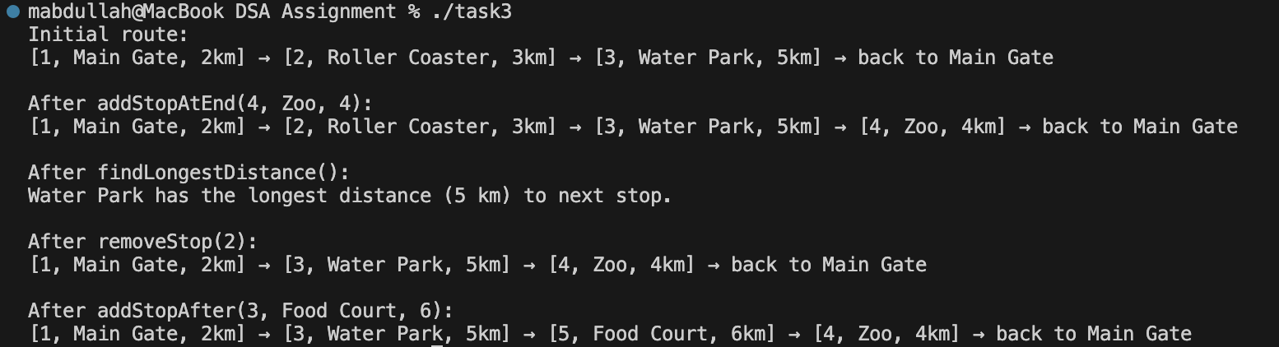

Explanation

→ Stop Structure
Represents one shuttle stop.
Each stop contains:
- id → unique stop ID
- name → stop name
- distanceToNext → distance (km) to the next stop
- next → pointer to the next stop in the circular list
→ ShuttleService Class
Manages the circular linked list of stops and provides functions to add, remove, display, and analyze routes.
→ addStopAtEnd(int id, string name, int distance)
- Adds a new stop at the end of the circular route.
- If the list is empty → the first stop points to itself (head->next = head).
- Otherwise, finds the last stop (whose next == head) and links the new stop before looping back to head.
→ addStopAfter(int id, int newId, string newName, int distance)
- Inserts a new stop after a given stop ID.
- Traverses the circular list until the stop is found.
- If found → inserts the new stop between current and next node.
- If not found → prints a message that the stop ID doesn’t exist.
→ removeStop(int id)
Removes a stop by its ID with full handling of edge cases:
- Empty list: shows “Route is empty!”.
- Single stop: deletes it and sets head = nullptr.
- Removing head: finds the last stop, updates head and last->next, then deletes old head.
- Removing middle stop: re-links previous node to skip the removed stop.

→ displayRoute()
Prints the full circular route in readable form:
[id, name, distanceToNext] → ... → back to headName
Traverses using a do-while loop to ensure every stop (including head) is printed once.
→ findLongestDistance()
Finds and displays the stop that has the largest distanceToNext.
Keeps track of the stop with the maximum distance while traversing the circular list.
→ main() Function
Demonstrates the shuttle system step-by-step:
- Adds 3 initial stops: Main Gate → Roller Coaster → Water Park
- Displays initial route
- Adds a new stop at the end → Zoo
- Finds and prints the stop with the longest distance
- Removes a stop (Roller Coaster)
- Adds a new stop Food Court after Water Park
- Displays the route after each change

Task 4:
Code Snippet

#include <iostream>
using namespace std;

class Node {
public:
string data;
Node* next;
Node(string data, Node* nextPtr = nullptr) : data(data), next(nextPtr) {}
};

class CircularList{
public:
Node* head;
Node* tail;
Node* cursor;
CircularList(Node* headPtr = nullptr, Node* tailPtr = nullptr, Node* cursorPtr = nullptr) : head(headPtr), tail(tailPtr), cursor(cursorPtr) {}

void insert(string data){
Node* newNode = new Node(data);
if (head == nullptr){
head = newNode;
tail = newNode;
tail->next = head;
cursor = newNode;
} else {
tail->next = newNode;
tail = newNode;
tail->next = head;
}
cout << "Inserted " << data << " at the end of the list.\n";
}

void undo(){
Node* current = head;
while (current->next->next != head){
current = current->next;
}
Node* temp = current->next; // 9 - 10 - 1, temp = 10
current->next = current->next->next; // 9 - 1, current = 9, current->next = 1 (head)
if (current->next == head){
tail = current;
tail->next = head;
}
delete temp;
cout << "Deleted Last Word" << temp->data << " from the list.\n";
display();
}

void find_and_replace(string data, string newData){
Node* current = head;
while (current->next->data != data){
current = current->next;
}
current->next->data = newData;
cout << "Replaced " << data << " with " << newData << " in the list.\n";
display();
}

void countWords(){
Node* current = head;
int count = 0;
do {
count++;
current = current->next;
} while (current != head);
cout << "There are " << count << " words in the list.\n";
}

void gotoNext() {
if (!head) {
cout << "List is empty.\n";
return;
}
cursor = (cursor == nullptr) ? head : cursor->next;
cout << "Cursor moved to: " << cursor->data << endl;
display();
}

void display() {
if (!head) { cout << "List is empty.\n"; return; }
Node* temp = head;
do {
if (temp == cursor) cout << "[" << temp->data << "] "; // mark cursor
else cout << temp->data << " ";
temp = temp->next;
} while (temp != head);
cout << endl;
}

};

void printMenu() {
cout << "\nText Editor - Circular Linked List\n";
cout << "-----------------------------------\n";
cout << "Select an operation:\n";
cout << "1. Insert word\n";
cout << "2. Undo (delete last word)\n";
cout << "3. Find and replace\n";
cout << "4. Count words\n";
cout << "5. Move cursor to next word\n";
cout << "6. Display text\n";
cout << "0. Exit\n";
cout << "Enter your choice: ";
}

int main() {
CircularList list;
int choice;
string word, newWord;

do {
printMenu();
cin >> choice;
cin.ignore(); // To clear newline from input buffer

switch (choice) {
case 1:
cout << "Enter word to insert: ";
getline(cin, word);
list.insert(word);
break;
case 2:
list.undo();
break;
case 3:
cout << "Enter word to find: ";
getline(cin, word);
cout << "Enter new word to replace with: ";
getline(cin, newWord);
list.find_and_replace(word, newWord);
break;
case 4:
list.countWords();
break;
case 5:
list.gotoNext();
break;
case 6:
list.display();
break;
case 0:
cout << "Exiting editor.\n";
break;
default:
cout << "Invalid choice. Please try again.\n";
}
} while (choice != 0);

return 0;
}

Output

Insert & display function

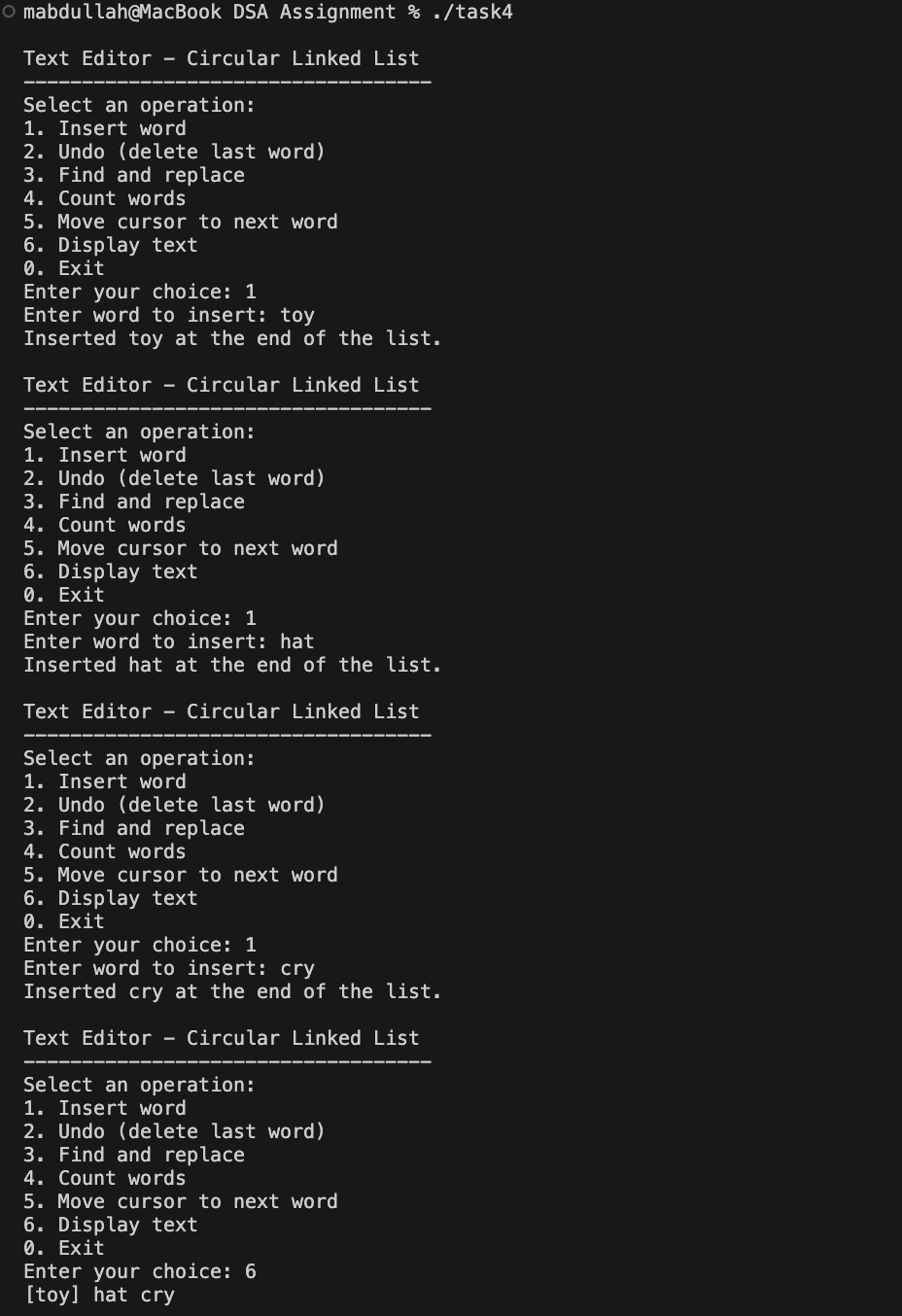

Replace function

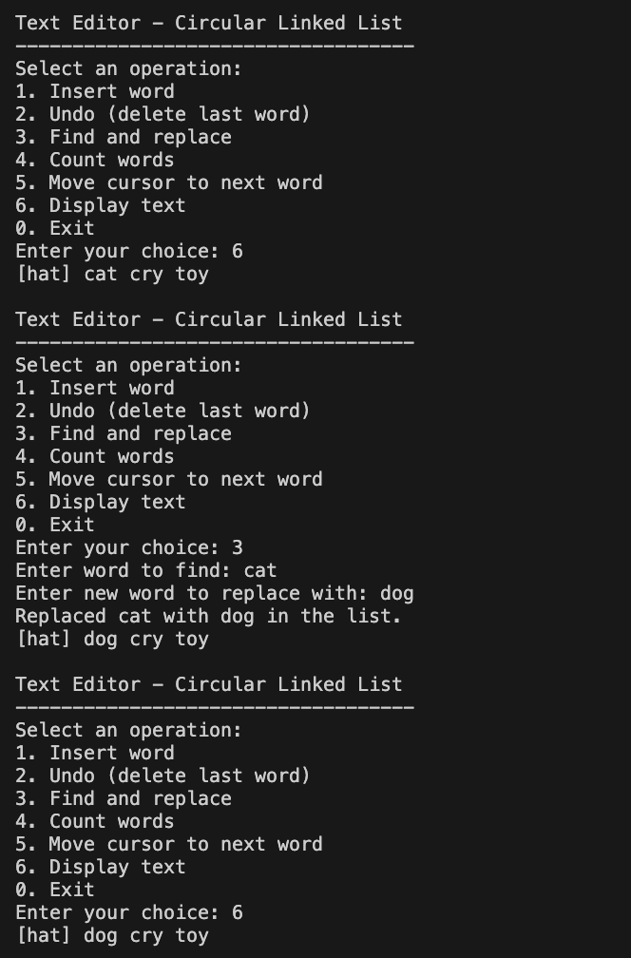

Cursor Function
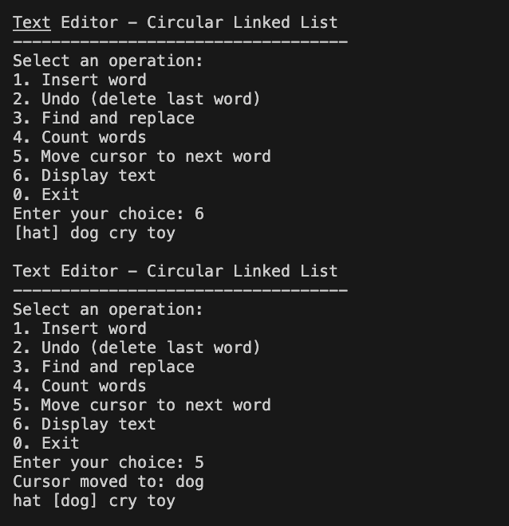

Count & Undo Function

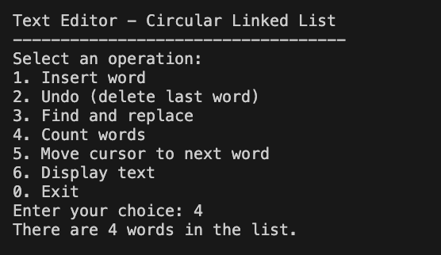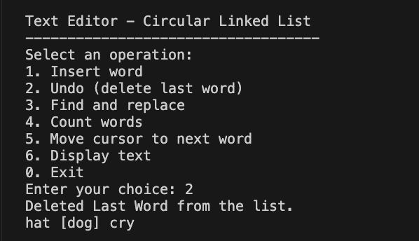

Explanation
→ Node Class
Represents a single word in the text. Each node contains:
- data → the word (string)
- next → pointer to the next node in the circular list
→ CircularList Class
Implements a circular linked list where:
- head → first word in the list
- tail → last word (points back to head to make it circular)
- cursor → pointer representing the current word (for navigation)
→ insert(string data)
Adds a new word at the end of the list. If the list is empty → initializes head, tail, and cursor to the new node and connects it circularly. Otherwise → attaches the new node after tail and updates links (tail->next = head). Prints confirmation and displays the updated list.
→ undo()
Deletes the last word (the tail node) from the list. Traverses to the second-last node, updates tail to it, and connects it back to head. Frees memory for the deleted node. Displays updated list after deletion.
→ find_and_replace(string data, string newData)
Searches for the given word (data) in the list. When found, replaces it with newData. Displays the updated list after replacement.
→ countWords()
Traverses the entire circular list once and counts all nodes. Prints the total word count.
→ gotoNext()
Moves the cursor to the next word in the list (circularly). If the list is empty → shows an appropriate message. Highlights the cursor position when displaying.
→ display()
Prints all words in the list in order. Marks the current cursor position with square brackets [ ] for clarity.
→ printMenu()
Displays the interactive text editor options:
1. Insert word
2. Undo (delete last word)
3. Find and replace
4. Count words
5. Move cursor to next word
6. Display text
0. Exit
→ main() Function
Implements a menu-driven text editor simulation using a circular linked list. Accepts user input for operations and performs actions like insert, undo, find-replace, count, navigation, and display dynamically.

Task 5:
Code Snippet

#include <iostream>
using namespace std;

class Node {
public:
Node* prev;
int tabID;
string websiteTitle;
string url;
Node* next;
Node(int tabID, string websiteTitle, string url, Node* prevPtr = nullptr, Node* nextPtr = nullptr)
: prev(prevPtr), tabID(tabID), websiteTitle(websiteTitle), url(url), next(nextPtr) {}
};

class BrowserTabManager {
private:
Node* head;
Node* tail;
Node* currentTab;

public:
BrowserTabManager() : head(nullptr), tail(nullptr), currentTab(nullptr) {}

void openTab(int tabID, string websiteTitle, string url) {
Node* newNode = new Node(tabID, websiteTitle, url, tail, nullptr);
if (!head) {
head = tail = newNode;
currentTab = newNode;
} else {
tail->next = newNode;
newNode->prev = tail;
tail = newNode;
}
cout << "Opened new tab: [" << tabID << "] " << websiteTitle << endl;
}

void closeTabByID(int id) {
Node* temp = head;
while (temp) {
if (temp->tabID == id) {
// Reconnect neighbors
if (temp->prev) temp->prev->next = temp->next; // if the tab has a previous tab, we need to link the previous tab to the next tab
else head = temp->next; // if the tab is the head, we need to link the head to the next tab, because head prev is nullptr.

if (temp->next) temp->next->prev = temp->prev; // if the tab has a next tab, we need to link the next tab to the previous tab
else tail = temp->prev; // if the tab is the tail, we need to link the tail to the previous tab, because tail next is nullptr.

// Adjust current tab
if (currentTab == temp)
currentTab = head ? head : nullptr;

cout << "Closed tab: [" << temp->tabID << "] " << temp->websiteTitle << endl;
delete temp;
return;
}
temp = temp->next;
}
cout << "Tab with ID " << id << " not found." << endl;
}

void switchTab(int id) {
Node* temp = head;
while (temp) {
if (temp->tabID == id) {
currentTab = temp;
cout << "Switched to tab: [" << temp->tabID << "] " << temp->websiteTitle << endl;
return;
}
temp = temp->next;
}
cout << "Tab with ID " << id << " not found.\n";
}

// Forward order.
void displayTabsForward() {
Node* temp = head;
cout << "-----Tabs (forward):-----\n";
while (temp) {
if (temp == currentTab)
cout << "-> ";
cout << "[" << temp->tabID << "] " << temp->websiteTitle << endl;
temp = temp->next;
}
}

// Reverse order.
void displayTabsReverse() {
Node* temp = tail;
cout << "-----Tabs (reverse):-----\n";
while (temp) {
if (temp == currentTab)
cout << "-> ";
cout << "[" << temp->tabID << "] " << temp->websiteTitle <<endl;
temp = temp->prev;
}
}
};

int main(){
BrowserTabManager browser;
cout << "-----Opening Tabs:-----\n";
browser.openTab(1, "Google", "https://www.google.com");
browser.openTab(2, "Facebook", "https://www.facebook.com");
browser.openTab(3, "Twitter", "https://www.twitter.com");
cout << "-----Displaying Tabs:-----\n";
browser.displayTabsForward();
browser.displayTabsReverse();
cout << "-----Closing Tab:-----\n";
browser.closeTabByID(1);
cout << "-----Displaying Tabs:-----\n";
browser.displayTabsForward();
cout << "-----Switching Tab:-----\n";
browser.switchTab(3);
cout << "-----Displaying Tabs:-----\n";
browser.displayTabsForward();
return 0;
}

Output

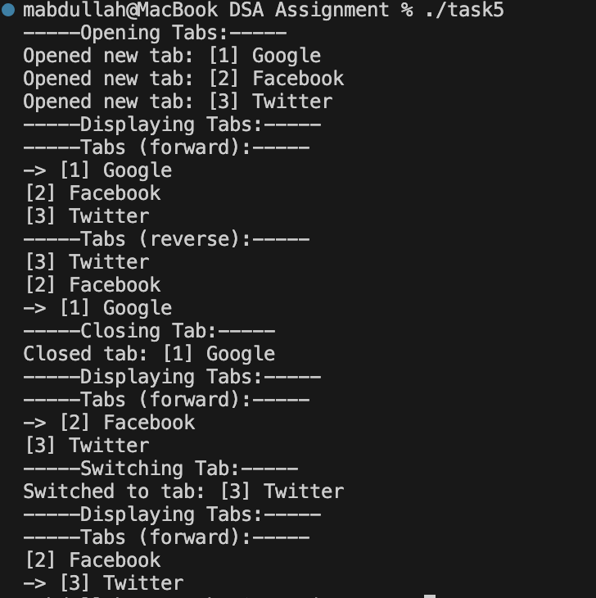

Explanation

→ The program simulates a browser tab manager using a doubly linked list.
→ Each tab is represented by a Node containing tabID, websiteTitle, url, and pointers prev and next.
→ The class BrowserTabManager maintains three pointers:
→ head → first tab in the list
→ tail → last tab in the list
→ currentTab → the tab currently active
→ openTab() → Creates a new Node and adds it to the end (tail) of the list.
→ closeTabByID() → Finds a tab by ID, reconnects its previous and next nodes, deletes it, and updates head/tail if needed.
→ switchTab() → Searches for a tab by ID and makes it the current active tab.
→ displayTabsForward() → Traverses from head to tail, printing all tabs and marking the current one with “->”.
→ displayTabsReverse() → Traverses from tail to head, printing all tabs in reverse order.
→ In main(), multiple tabs are opened, displayed, one is closed, and switching between tabs is demonstrated.

